Banning Stagecoach Days Association Presents
Battle of the Bands 2017
Local bands will compete for $500 at the 2015 Banning Stagecoach Days on Sunday, September 10, 2017. Contestants will be judged on their technical performance, originality of songs, professionalism, stage presence, vocals and audience reaction. The winners will be announced at the end of the competition.

Eligibility: Application form, park entry presale tickets (#20 @ $5 each), set list WITH lyrics (must have one cover song) that you plan on performing for the contest, and a photo of your band.
DO NOT INCLUDE DVDs OR PICTURES LARGER THAN 8.5 X 11 INCHES. Applications must be received no later than Friday, August 25, 2017 at 5:00PM. A meeting will be held on this day for all participants at A.C. Dysart Park to confirm enrollment and to pick-up entry tickets (#20 at $5 each) for presale. SIGN UP NOW!!!
**Stagecoach Days Association will neither retain nor return the materials submitted.
Rules and Regulations:
• Contest will be limited to eight bands maximum.
• Each band will be allowed a maximum of 30 minutes for its performance.
• All band members MUST reside in Southern California.
• Set must include at least one cover song.
• This is a family event: NO FOUL LANGUAGE, INAPPROPRIATE ACTIONS OR ATTIRE. CONTESTANTS WILL BE DISQUALIFIED IF THE RULES ARE NOT FOLLOWED. BANDS THAT FAIL TO ABIDE BY THESE RULES WILL BE REMOVED FROM THE STAGE.
Day of the Event:
• List of the bands’ order will be distributed on or before the event.
• All band members must arrive for set up no later than 11:00am, on Sunday, September 10th. Start time is 12:00PM for the event. Failure to do so will result in up to a 10-point deduction from your band’s final score (one point for each minute late).
Length of Performance:
Performances may be no longer than 30 minutes maximum. Ten minutes are allotted for setting up and tearing down. Between sets, please plan accordingly. Up to 10 points can be deducted from the judges’ raw score for delays in set changes. You have 10 minutes for set up, 30 minutes to play your set and another five minutes for teardown in order to feature as many bands as possible. Equipment changes between bands must flow smoothly. Be prepared so we can stay on schedule!
Please return your completed application and materials to:
Stagecoach Days Association PO Box 604 Banning, CA. 92220

Stage Information:
The stage location will be at the main stage at A.C. Dysart Park, 2101 W. Victory Ave., Banning, CA. 92220
Music Accompaniment:
The microphones and PA, will be provided. Please bring bass guitar and guitar amps, drums, keyboards, guitars, cymbals and drum hardware or anything else you require that is not listed. Bands are responsible for any Battle of the Bands equipment damaged or lost during their set-up, set, or tear-down.
Selection Criteria:
Each application will be reviewed by a Battle of the Bands Selection Committee on the basis of the following:
1. Timely receipt of a completed application. Applications received after 5:00 p.m. on Friday, August 25, 2017 will not be reviewed.
2. Entry ticket presale money must be turned in by 5:00PM on Friday, Sept. 8, 2017.
3. Uniqueness and appeal of performance.
4. Material to be performed must be appropriate for a family audience.
NO FOUL LANGUAGE, INAPPROPRIATE ACTIONS OR ATTIRE. CONTESTANTS WILL BE DISQUALIFIED IF THE RULES ARE NOT FOLLOWED. BANDS THAT FAIL TO ABIDE BY THESE RULES WILL BE REMOVED FROM THE STAGE.
5. Overall dress & presentation. The Stagecoach Days Association is a “family event” and all performers should reflect that.
6. Bands must be able to be at the Fairgrounds on Sunday, September 10, 2017 from 11:00 a.m. until 6:00 p.m.
Bands will be selected on Monday, August 29, 2016. Bands selected will be notified by phone or email no later than Monday, August 29, 2016.
Credential and parking information will be provided once the band selection has been made.
The sole decision for the selection rests with the Fair Management. The Stagecoach Days Association has the right to reject any application for any reason.
Merchandise:
Bands may sell band merchandise (CDs, T-shirts, and posters) in an area that will be set up 15 minutes prior to show time and will close 15 minutes after show time. The merchandise booth will be shared with all bands that choose to take advantage of this opportunity. Only band merchandise can be sold at the booth. Items that do not reflect the band cannot be sold at the merchandise booth. The Stagecoach Days Association are NOT responsible for loss or theft of cash or merchandise, please make sure you have a person to be responsible for your items.
Please return your completed application and materials to:
Stagecoach Days Association PO Box 604 Banning, CA. 92220

Judging: Contestants will be judged on a 60 point system:

• Technical Performance - Max Points: 10
(How well the band members use their instruments)

• Audience Reaction - Max Points: 10
(Audience applause, yelling, screaming, and/or dancing)

• Vocals - Max Points: 10
(Singer’s voice complements the music and voice quality)

• Originality of Songs - Max Points: 10
(Song construction, expressions and blend of vocals and music)

• Stage Presence - Max Points: 10
(Interaction with the crowd, band is having fun and are fun to watch)

• Professionalism - Max Points: 10
(Dress and act appropriately, move efficiently during set changes, show respect for the audience)

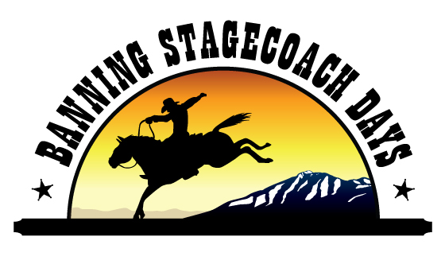
Deductions:
• Set Time Max Points: -10
(Band did not meet 30-minute time limit)

• Late Arrival Time Max Points: -10

• Inefficient set up time between sets Max

Bands will be disqualified and removed from the stage for inappropriate behavior, language, or clothing.

Please return your completed application and materials to:
Stagecoach Days Association, PO Box 604 Banning, CA 92220

ENTRY FORM: Competition takes place Sunday, September 10, 2017
Name of band performing:
______________________________________________________________________________
Name of person submitting application and relationship to the band:
______________________________________________________________________________
Applicant address: ______________________________________________________________________________
City: __________________________________State _______________ Zip: _______________
Day time contact phone number: (________)_______________________________________
E-mail address: ________________________________________________________________
Best time to be contacted: _______________________________________________________
Number of people in band: ______ Will you be selling merchandise? Yes_____ No______
BAND MEMBERS NAMES AND INSTRUMENTS PLAYED
1)____________________________________________________________________________

2)____________________________________________________________________________

3)____________________________________________________________________________

4)____________________________________________________________________________

5)____________________________________________________________________________

How did you hear about this contest?

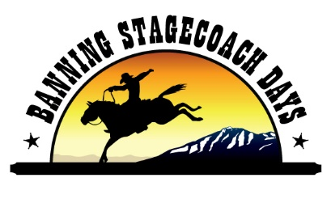
Along with this application please provide:
• Expected song set list WITH lyrics
• Demo CD
• Photo of your band
The Stagecoach Days Association will neither retain nor return these items.

You and your band wish to enter the Stagecoach Days Association Battle of the Bands Contest and agree to abide by the rules provided by the Stagecoach Days Association. I certify that all information provided above is true and accurate.
Your signature indicates that you have agreed to abide by all rules and regulations as published on the forms provided.

Print Name: ___________________________________________________________________________
Signature:_____________________________________________________________________________

Representative Signature: ________________________________________ Date: _________________
(Parent or guardian must sign for minor under the age 18)
Continued on back…
Please return your completed application and materials to:
Stagecoach Days Association PO Box 604 Banning, CA. 92220
Contestant Media Information Form The following information will be provided to the Fairgrounds Media Department for publicity purposes and to the MC of the Contest.
Name of band: ______________________________________________________________________________________
Contact name: __________________________________ Phone Number: ________________________
How many members are in your band? ______________________________________________________________________________________

What community is your band from? ______________________________________________________________________________________

How long has your band been performing together? ______________________________________________________________________________________

How did your band come together? ______________________________________________________________________________________

What makes you band unique? ______________________________________________________________________________________

What venues have you played? ______________________________________________________________________________________

______________________________________________________________________________________

______________________________________________________________________________________

Describe your musical style ______________________________________________________________________________________

______________________________________________________________________________________

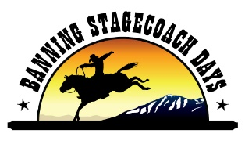
Please return your completed application to:
Banning Stagecoach Days – Battle of the Bands
Attn: Carla Sanchez
PO Box 604 Banning CA. 92220
stagecoachdays@yahoo.com (951) 847-8556

CHECKLIST OF MATERIALS DUE BY Friday, August 26, 2016 at 5:00PM:

o Application form completely filled out and signed including the media information, contact
person, and signature that shows that you read and understand the rules.*
o A photo of your band (.jpg format if e-mailing)*
o Song set list WITH lyrics (at least one cover song)*
o 20 entry tickets ($5 each) to the Stagecoach Days Event paid for by 5:00PM on Sept. 9, 2016*

THESE ITEMS WILL NOT BE RETURNED*

